**Acknowledgement**

**I would like to thanks my Associate Professor Mr. Mudit Khetan and my Asst. Director Mr. Navneet Kumar Verma who continuously guide me during the whole course of my project. I would also like to thank my friend Abhijit for his assistance and insightful comments and who willing to share his experience with me.**

**I sincerely acknowledge and thank my family members and friends who gave moral support for me from my childhood.**

**CERTIFICATE FOR PROJECT COMPLETION**

This is to certify that **Mr. Kishan Kumar S/O Sh. Kailash Nath Pandey** has Successfully Completed the project work titled **“Book E-Rental Store”** in partial Fulfillment of requirement for the award of **Under-Graduation (B. Tech Computer Science and Engineering)** prescribed by the **Jaipur National University (Seedling Academy of Design Technology and Management).**

This Project is the record for authentic work carried out during the academic Session

(Jan 2017 – May 2017).

Under-Guidance of Mr. Mudit Khetan and Mr. Navneet Kumar Verma.

**Date of Completion -: 3rd May 2017**

**Signature of Student**

**Signature of External Faculty Signature of Internal Faculty**

**Signature of HOD. Signature of Director.**

**Abstract**

All book lovers want to read as many books as they can lay their hands on, but most of them either cannot afford them to buy, or do not have a proper home space to store them, or simply do not have options to first read the book and then decide to buy them. If a library provides them the facility to browse and loan the books/magazines of their choice, then certainly they would be able to read more books and many would end up buying them. The library system has an inherent problem that it is not self-sustaining and always has paucity of funds due to its dependence on donors and grants. Similarly, the donors and funding agencies impose their choice on the librarians to only offer those books and magazines which they deem “fit” for the readers. The popular choice of the readers and current/latest books are mostly not available in such libraries, barring a few exceptions.

If a library works on the principle of self-sustainability by earning from the loaned books, it can better suit the needs of the readers and can grow over a period of time. That is where the concept of BERS comes into play.

The main objective of the project is to create an online book/magazine (referred to herein as books) rental store that allows users to search and rent them online, after becoming members. The books catalogued and indexed on many filters (like title, author, category, genre, etc.) and allow filtering based on these. The website would be aesthetically pleasant and easy to use for the targeted users. The rental store would take security deposits from members that can be deposited through online payment facility. Using this Website, the user can rent a book online instead of going out to a library/stores and wasting time in browsing the book.

There are many online book stores like Powell’s, Amazon. I want to develop a similar website using JavaEE and Oracle 10g.

This application is developed using JavaEE programming language. The Master page, data sets, data grids, user controls are used to develop the Online Book E-Rental store.

**Table of Contents**

**Description Page No.**

1. **Introduction** 
   1. Objective 05
   2. Scope 05
   3. Definition, Acronyms, and Abbreviation 06
   4. Overview 06
2. **Overall Description**
   1. Product Perspective 07
   2. Product Function 08
   3. User Roles and Functions 10
   4. Constraints 10
   5. Architecture Design 11
3. **Feasibility Study**
   1. Cost Estimation (COCOMO Model) 12
   2. Feasibility Report. 12
4. **System Design**
   1. Entity Relational Diagram 17
   2. Relational Diagram 18
   3. Sequence Diagram 19
   4. Data Flow Diagram 27
5. **Test Cases**
   1. Unit Testing 29
   2. Integration Testing 33
   3. System Testing 33
6. **Coding**
   1. Module and Unit Definition 33
   2. Interface Definition 35
   3. Graphical User Interface 37
7. **Implementation**
   1. Application Server Setup / Configuration. 46
   2. DB Server setup / Configuration. 46
   3. 3rd Party Tools and Libraries 46
8. **References** 47
9. **APPENDIX A**

**Software Requirements Specification**

1. **Introduction**
   1. **Objective**

The Main Objective of the project is to create an Book E-Renal Store for the users who are willing to read the book but they cannot buy that book, for them we are providing them a rent facility which makes their Burdon less. Book Store allows users to search the book on Basis of Different Category market like fiction, Science, Technology, Romance etc.

* 1. **Scope**

The software system being produced is called Book E-Rental Store. It is being produced for the customers interested in getting book’s on rent via the Internet. This System is designed to “Provide Automation Support” for placing book for rent on the Internet and Facilating the actual Sale. This System is largely cross-platform and is available to anyone On Internet. This System will be run on a central server with user having a remote user interface through a web browser to interact with it.

* There are three basic users – Anonymous(Guest), Registered Members(customers), Library Staffs, Administrator
* The customer, through the process of account creation, will have the option to Become a member of the site.
* The system will allow customers to browse, search, select, and add books to a rental cart.
* Admin/Sr. Librarian has the authority to add/delete users, grant permission to members/Staff and users to rent book and in return is also responsible for generating mobile message for customers regarding book rental transaction and delivery.
* Pick up Facility and The Online Transaction Facility Where will be provided to our customers.
* We Are providing additional facility to our customers who are interested in Magazines and Newspaper Can Rent It.
  1. **Definition, Acronyms and Abbreviations**
* **Admin -:** He has authority to add/delete users, grant permission to Staffs and can add/delete books and he/she can change the Database Model etc.
* **Sr.** **Librarian -:** He has Authority to add/delete users, grant permission to staffs, can generate reports, etc.
* **Jr. Librarian -:** He has the authority to generate reports collect fines, payments etc.
* **Java -:** Java language is intended to be simple, modern, general purpose, Object-Oriented Programming Language.
* **Oracle 10g -**: It is a relational database server, is a software product whose primary function is to store and retrieve data as requested by other Software application.
* **HTML -**: It is a Hypertext Markup Language used to design client side static web pages.
* CSS -: **Cascading Style Sheets** is Used for managing and formatting layout of HTML web pages.
* **HTTPS -: Secured Hypertext Transfer Protocol: It’s** a service protocol.
  1. **Overview**
     1. **Existing System**
* Manual Registration
* Only E-Book Are Available for Rent by Amazon, Powerwell etc.

Abstraction in E-Rental Stores

* + 1. **Drawbacks**
* No Supports for Logistics.
* Limited Options (For Few Starting Months)
  + 1. **Proposed System**
* Online Registration Facility.
* Centralized Maintenance of Book Data.
  + 1. **Our Plan**
* Acknowledgment for Registration, sales and Arrival of New Books.
* Feedback from Users.
* New Users Registration.
* Providing Free E Magazines to All Users Including Anonymous Users.
* Notification On User Dashboard of Their Rent and Books status.

1. **Overall Description**
   1. **Product Perspective**

Host/Client

Server

BERS is an online bookstore website which support a number of functions for both the consumers and store’s management.

The Website must be available to anyone using the Internet and as such must work correctly in Mozilla, Chrome, Internet Explorer. As stated by the customer, there are no hardware or software requirements beyond these including, but not limited to memory or specific software package that need to be utilized nor software packages that need not to be utilized.

* 1. **Product Function**

E-Book Rental System will help to know automatically when certain book requested by them has arrived and their rental due dates once they register with the organization.

Some of the features of the product are as followed:

* Main data Associated with the inventory
  + A book has a Title, Author, ISBN and Price etc.
  + The Inventory also keep track of stock/quantity of each book.
* Maintain Records of the users.
  + A user can be either a member or staff.
  + A Customer has a Username (Unique across all User), Password (Condition), Email, address, Postal code, Cell No., Etc.
  + Anyone may sign up to become a member.
* Allow Any Authenticated User to Become a Member.
* Show a listing of available Books
  + Books are to Be Displayed in Ascending Order Alphabetical order as Per Search.
  + Each Book will list the following from left to right
    - Title
    - Author
    - Price, Etc.
* Allow User’s to login and logout of the System
  + Users will Be logged out if inactive for 30 Minutes.
* Rental Cart
  + Registered(Customers) User’s is able to add one or more books to the rental cart.
    - The Rental cart does not allow multiple copies of any Book.
* User Can discard any items from cart before final Transaction.
* Checking Out
  + Checkout is Only Available to registered users. A user that is not logged in as a user is given a chance to log in.
  + Online Transaction Facility Is Provided
    - Collect The Card Number and CVV Code.
* Log/Record of Every Transaction is Maintained
* Pick Up Facility Is Only Provided for Any Rental Transaction.
* Allow Staff to stop any User Rental Order and Notify Him/her
  + Each Book has its own stop-order status, before packing if book condition is Bad and no Other Book is available in stock then staff can stop the order and update it as disposal.
* Notify Staffs when book need to be reordered
  + When the quantity of a book falls below a threshold, the staff is notified that the book needs to be reordered.
* Allow staff to update the stock of book
  + Allow staffs to change any book’s price.
  + Allow staffs to view transactions log.
  + Allow Staffs to View and Generate Reports and receipts.
* One Exception is if staff has already specified a stop-order for the book.
  + Every Book Must either have stop-order enable or disable.
* Allow Administrator to generate Notifications for the users.
* It will ease and speed up the planning decision making process, secure confidential and reliable reports
* It automated the system with the help of Email that informs the user about the availability, price and method of purchasing the book.
* It mainly emphasized creation and implementation of a book sales management information system.
* It focused on the acquisition, distribution and management of books.
  1. **User Characteristics**
  + **Guest/Anonymous:** Non-Members can visit us and can access free services.
  + **Members:** Register Members can access all the functionalities provided on websites. Registered Member have their own profiles.
  + **Staff:** The staffs are divided into 2 categories
    - **Jr. Librarian:** Have Authority to control transactions and can add/delete the Books Details Can Fine Any Member for Violation of rules, prepare the delivery packets to be picked up by Members.
    - **Sr. Library:** Have Authority to control transactions and can add/delete the books/Users detail can Fine Any Member for Violation of Rules, maintain pickup Facility, Can Change Business Rule, Can View User Profiles ETC.
  + **Administrator:** All Facility of Staffs and Members are available to Admin and it have authority to Change Anyone Password by entering Essential Credentials, Can Modify the Database Model ETC.
  1. **Constraints**
* The information of all users must be stored in a database that is accessible by the administrator.
* Book E-Rental Store is running all 24 hours a Day but for Returning and Pickup Timing is fixed.
  + **Timing:**
    - **Pickup Timing: 8:00 Am to 8:00PM**
    - **Return Timing: 8:00 Am to 9:00 Am and 4:30 Pm to 5:30 PM**
* The User Can Access Book E-Rental Store from any Computer that has Internet browsing Capability and an Internet Connectivity.
  1. **Architecture Design**

**Note -:** Sales Here is Rental

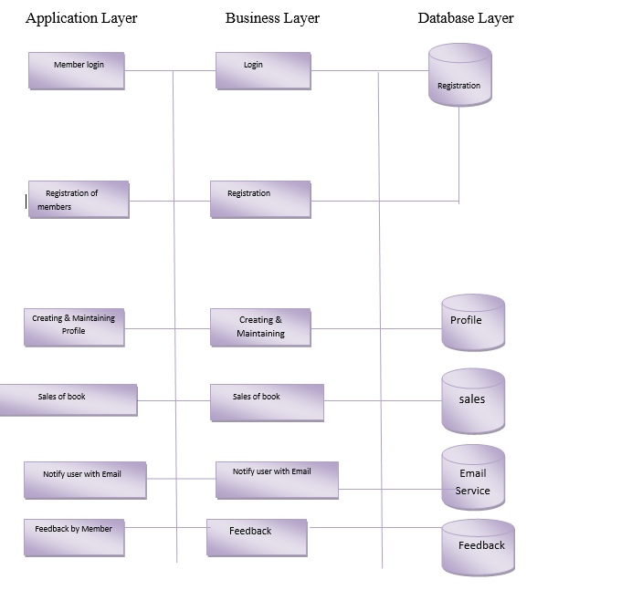

1. **Feasibility Study**
   1. **COCOMO MODEL**

Project effort and time will be estimated using the COCOMO estimation model (Barry Boehm)

The Book E-Rental Store has an Average complexity and moderate flexibility. Therefore, it is classified as an organic mode project under the **COCOMO** model. The Following Formula is the **COCOMO** model for the cost estimation for organic mode projects:

**Effort =** number of staff months (PM)

**EAF** = effort Adjustment Factor.

**SIZE =** Number of Lines of Code for Completed product. It is measured in **KLOC (thousands of lines of Codes.)**

**TIME =** Total Number of Months.

COCOMO uses two equations to calculate effort in man months (MM) and the number on months estimated for project (TDEV)

MM is based on the number of thousand lines of delivered instructions/source (KDSI)

MM = a(KDSI)b * EAF

TDEV = c(MM)d

EAF is the Effort Adjustment Factor derived from the Cost Drivers, EAF for the basic model is 1

The values for a, b, c, and d differ depending on which mode we are using

|  |  |  |  |  |
| --- | --- | --- | --- | --- |
| **Mode** | a | b | c | d |
| Organic | 2.4 | 1.05 | 2.5 | 0.38 |
| Semi-Detached | 3.0 | 1.12 | 2.5 | 0.35 |
| Embedded | 3.6 | 1.20 | 2.5 | 0.32 |

The Effort Adjustment Factor is the product of the 15 adjustment parameters. Each Adjustment parameter is categorized as very low, low, nominal, high or Very high. All The Parameter Adjustment parameter are listed Below:

1. **RELY** Required Reliability 0.75 – 1.40
2. **DATA** Data Size 0.94-1.65
3. **CPLX** Product Complexity 0.70 – 1.65
4. **TIME** Execution time constraint 1.00 – 1.66
5. **STOR** Main storage constraint 1.00 – 1.56
6. **VIRT** Virtual machine volatility 0.87 – 1.30
7. **TURN** Computer turnaround time 0.87 – 1.15
8. **ACAP** Analyst capability 1.46 – 0.71
9. **AEXP** Applications experience 1.29 – 0.82
10. **PCAP** Programmer capability 1.42 – 0.70
11. **VEXP** Virtual machine experience 1.21 – 0.90.
12. **LEXP** Language experience 1.14 – 0.95
13. **MODP** Use of modern practices 1.24 – 0.82
14. **TOOL** Use of software tools 1.24 – 0.83
15. **SCED** Required development schedule 1.23 – 1.10

The Adjustment Factor for E-Book Rental Store are listed Below-:

**Note**-: **Allotment of Appropriate Values for the above listed parameters requires experience of more than one project cycle as well as many sophisticated tools. Therefore, for such parameters a nominal Value of ‘1’ is Used for Calculation.**

1. **RELY 1.00 Nominal**
2. **DATA 1.00 Low**
3. **CPLX 0.85 Low**
4. **TIME 1.00 Nominal**
5. **STOR 1.00 Nominal**
6. **VIRT 0.87 Low**
7. **TURN 0.87 Low**
8. **ACAP 1.00 Nominal**
9. **AEXP 1.13 Low**
10. **PCAP 1.00 Nominal**
11. **VEXP 1.00 Nominal.**
12. **LEXP 1.00 Nominal**
13. **MODP 0.91 High**
14. **TOOL 0.91 High**
15. **SCED 1.00 Nominal**

The **EAF** value evaluated to 0.60. I have estimated the size to be around **3.00**

From The Calculation, I Got

**Effort = 6.09**

**Time = 5.00**

**Note-: T**he calculation study and Cocomo Model Study is Done from Paper **COCOMO Models for E-commerce Application By-:** Ramesh Kumar.

The Detailed Calculation Can’t Be Shown right now because my project is under Work and Above Results are my estimate which may change in future after final completion of my project and all detailed data will be shown after my work get completed.

* 1. **Feasibility Report**
     1. **Technical Feasibility-:**

The Book E-Rental Store is feasible technically, although there is some risk.

**Rumors Group Book E-Rental Store risk familiarity with Internet order application is high.**

* The Marketing Department is there.
* The IT Department Consists of Single Person (Kishan Kumar) Under (Mr. Mudit Khetan and Mr. Navneet Verma) who have strong knowledge of the Company Existing System. However, he has not worked with Web-enabled order System.
* Many Retailers in Market Exist.

**Rumors Group Book E-Rental Store Risk Regarding familiarity with the technology is medium.**

* The IT Person is relying on external Consultants and Internet Services provider to develop its existing Web Environment.
* The IT person has gradually learned about Web System by maintain The Current Project.
* Development tools and products for commercial Web Application development are available in the Market, although the IT Person has Little Experience with Them.
* Consultant are readily available to provide help in this area.

**The Project Size is Considered Medium Risk**

* The project team is likely will includes 3 Persons.
* Business User involvement will be required.
* The project timeframe cannot exceed 6 months because of End Sem Exam is deadline for Implementation, and it should be much sorter.

The Compatibility with Rumors Group Book E-Rental Store existing technical Infrastructure should be good.

* The Current Order System is Client-Server System Built Using open standards. An Interface with the Web Should Be Possible.
* Retail Stores already place and maintain Order Electronically.
* The ISP should be able to scale their services to include a new Order System.
  + 1. **Economic Feasibility**
* A Cost Feasibility analysis was performed: A Business Rules Excel Sheet is Attached for Details.
* The Growth in Next 2 Years will Be Approx. 25.00%.

Intangible Costs and Benefits

• Improved customer satisfaction

• Greater brand recognition

1. **System Design** 
   1. **Entity Relational Diagram**

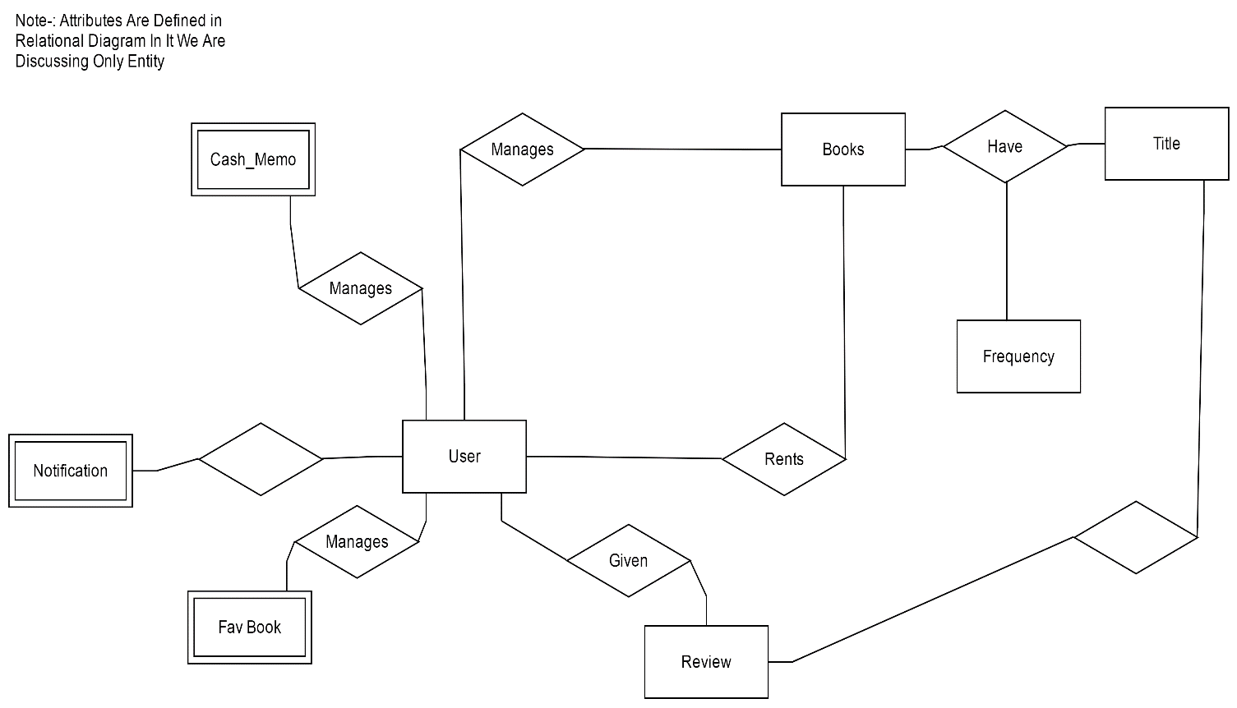

* 1. **Relational Diagram**

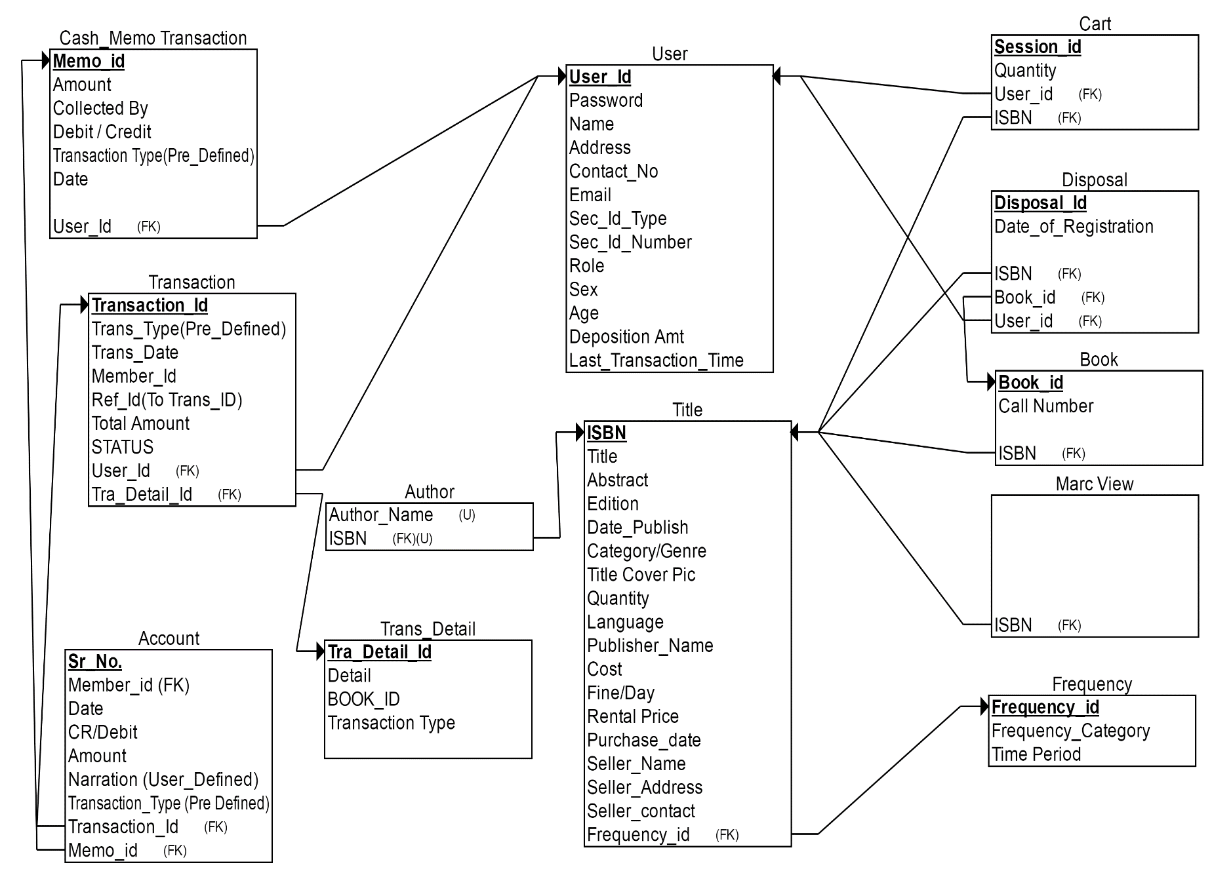

**Note-: The Independent Tables Are Not Shown in The Diagram.**

1. **Fav Book**
2. **Narration etc.**

**Sequence Diagram**

* + 1. **Login**

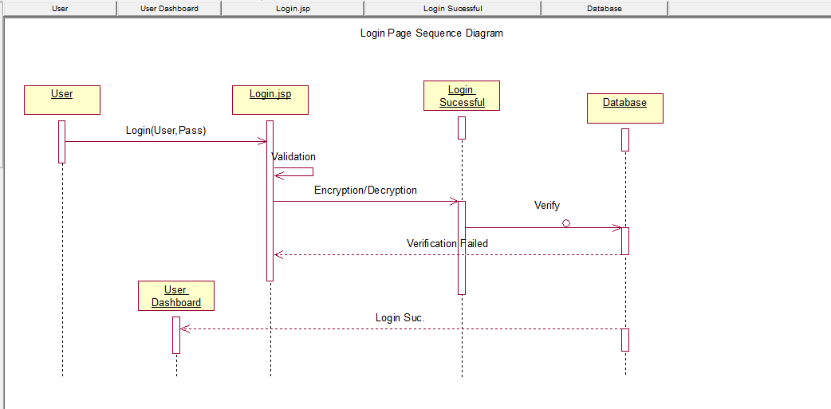

* + 1. **Logout**

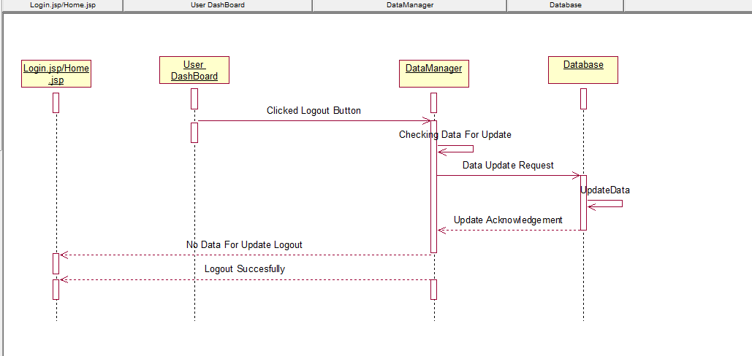

* + 1. **Registration**

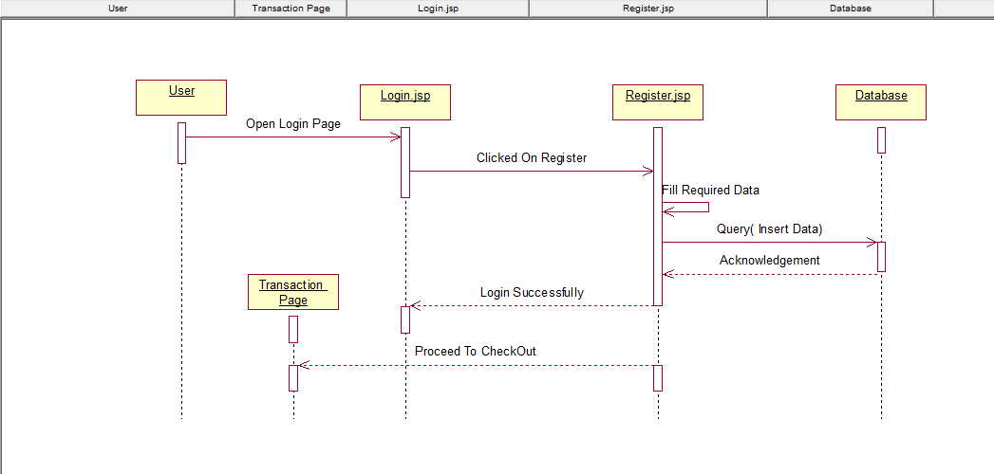

* + 1. **Transaction**

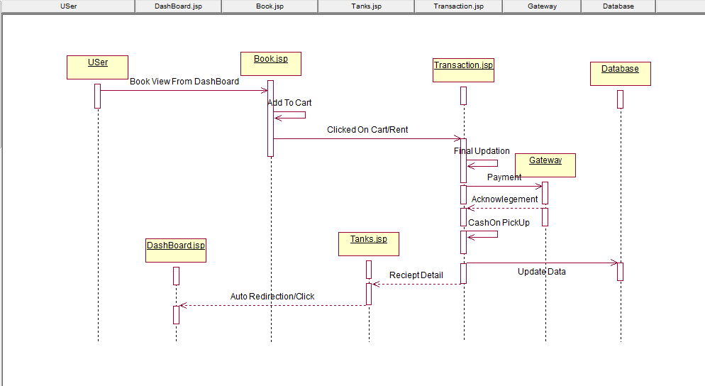

* + 1. **Notification**

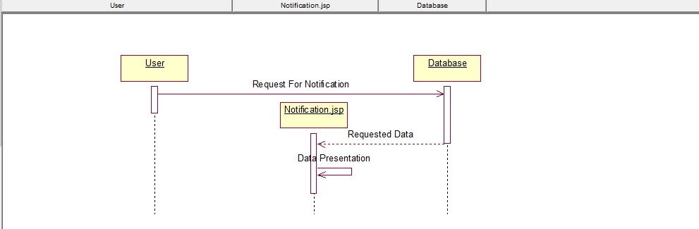

* + 1. **Report Generation**

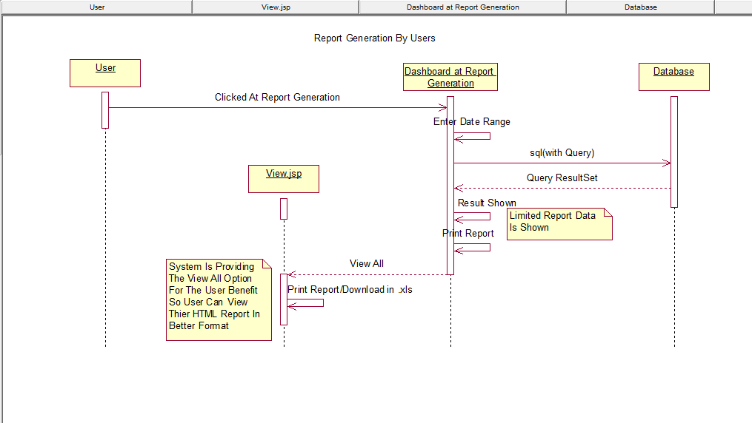

* + 1. **Book Search**

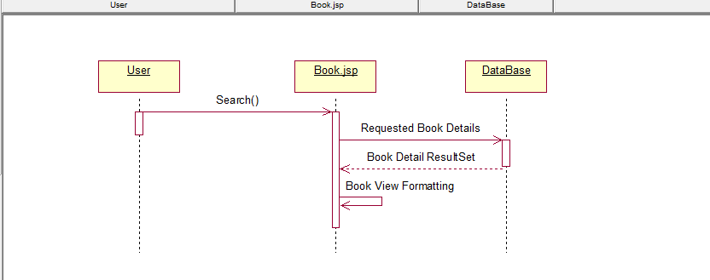

* + 1. **Book /User Addition and Deletion**

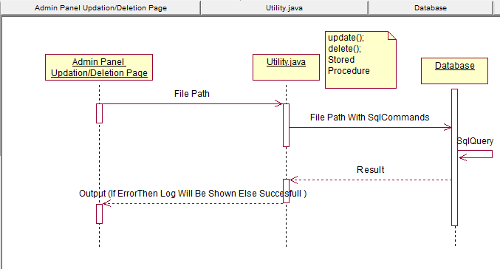

* 1. **Data Flow Diagram-:**
     1. **Level 0:**

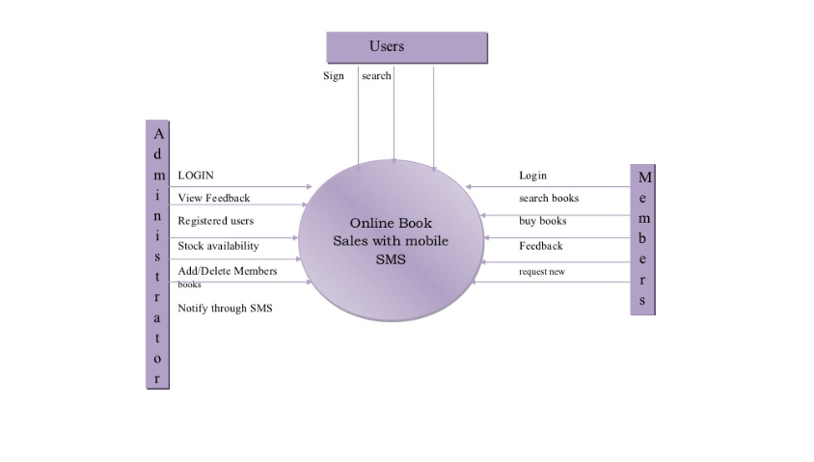

* + 1. **Level 1:**

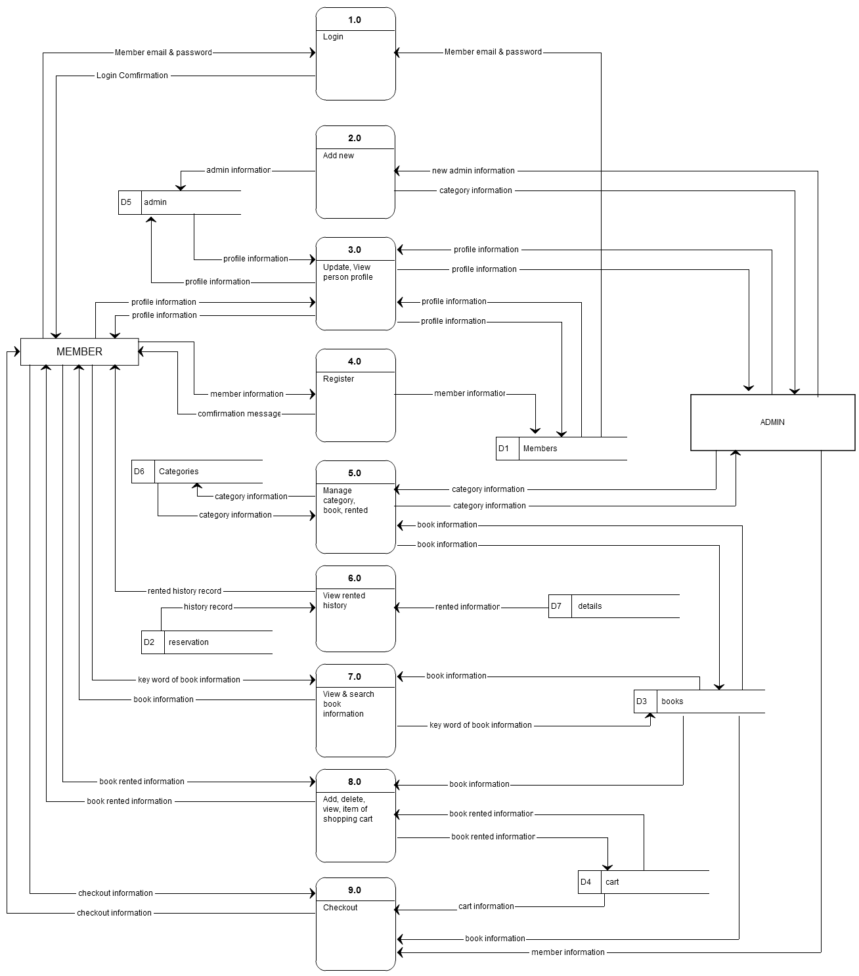

1. **Test Cases**
   1. **Unit Testing**
      1. **Features to be tested**

The Following list describes the features to be tested.

**User:**

* Registration
* Login
* Cart
* Edit Cart
* Forgot Password.
* History Report.

**Staff:**

* Create and Delete books.
* Create or Delete Frequency
* Manage Order
* Manage Members
* Manage Report

**User**

1. **Registration**

|  |  |  |  |
| --- | --- | --- | --- |
| Id | Test Case | User Input | Pass Criteria |
| U_REG_1 | User Reg. | User Selected already existing Username | Display Message to Choose Different User Name |
| U_REG_2 | User Reg. | User enters different in password confirm field | Display Message that Password and Confirm Password field don’t match |
| U_REG_3 | User Reg. | User Forgot to enter a particular field | Display message The Value in Field is Required. |
| U_REG_4 | User Reg. | User Enters all the Detail Successfully | User Account Created |

1. **LOGIN**

|  |  |  |  |
| --- | --- | --- | --- |
| **ID** | **Test Case** | **User Input** | **Pass Criteria** |
| U_LOG_1 | User Login | User Enters a Wrong Username | Display Message Username and Password is Incorrect. |
| U_LOG_2 | User Login | User Enters a Wrong Password | Display Message Username and Password is Incorrect. |
| U_LOG_3 | User Login | User Enter Correct Username and Password | User login Successfully. |

1. **Add to Cart.**

|  |  |  |  |
| --- | --- | --- | --- |
| **ID** | **Test Case** | **User Input** | **Pass Criteria** |
| U_AC_1 | Add To Cart | User Select an item and click add to cart button | Book is Added To Shopping Cart |
| U_AC_2 | Add To Cart | Guest Select an item and Click add To Cart Button | Book is Added To Shopping Cart (At Buying Time Create an Account) |

1. **Edit Cart**

|  |  |  |  |
| --- | --- | --- | --- |
| **ID** | **Test Case** | **User Input** | **Pass Criteria** |
| U_EC_1 | Edit Cart | User Deletes an item from Cart | Item and Total Cost Of Cart should be Updated |
| U_EC_2 | Edit Cart | User add a new item in cart | Item and Total Cost Of Cart should be Updated |
| U_EC_3 | Edit Cart | At Logout Time | Check Cart Items if any change is their then store to Database. |

1. **Forgot Password**

|  |  |  |  |
| --- | --- | --- | --- |
| **ID** | **Test Case** | **User Input** | **Pass Criteria** |
| U_FP_1 | Forgot Pass. | Entered Wrong Username And Email | Display User or mail is Not Present. |
| U_FP_1 | Forgot Pass. | Enter Correct Username and Email | OTP Verification Code Send On Registered Mail Id. |

1. **History Report**

|  |  |  |  |
| --- | --- | --- | --- |
| **ID** | **Test Case** | **User Input** | **Pass Criteria** |
| U_HR_1 | Report | Wrong Date Range Input | Display Enter The Correct Range |
| U_HR_2 | Report | Only Starting Date Provided as Input | Display Report from Starting to Current Date of System. |
| U_HR_3 | Report | Specific Range is Provided as Input | Report Generated Of Given Range |

**Staff**

1. **Create and Delete Items**

|  |  |  |  |
| --- | --- | --- | --- |
| **ID** | **Test Case** | **Admin Input** | **Pass Criteria** |
| AD_CDB_1 | Create and Delete an Item | Wrong Data Input is given by Admin. | Error According To Exception is Shown |
| AD_CDB_2 | Create and Delete an Item | Admin Adds a new Item to Database | Book Should be Updated in Categories list. |
| AD_CDB_3 | Create and Delete an Item | Admin deletes a book from category | Book should be Deleted in Categories list. |

1. **Create or Delete or Update Frequency**

|  |  |  |  |
| --- | --- | --- | --- |
| **ID** | **Test Case** | **Admin Input** | **Pass Criteria** |
| AD_CDC_1 | Create and Delete | Admin Add/Update a New Frequency | Category Should be updated to System |
| AD_CDC_2 | Create and Delete | Admin Deletes a category | Category should be deleted from category |

1. **Manages Orders**

|  |  |  |  |
| --- | --- | --- | --- |
| **ID** | **Test Case** | **Admin Input** | **Pass Criteria** |
| AD_MO_1 | Manages Orders | Admin accepts an order. | Order is Processed |
| AD_MO_2 | Manages Orders | Admin deletes an Order. | Order is not processed. |

1. **Manages Members**

|  |  |  |  |
| --- | --- | --- | --- |
| **ID** | **Test Case** | **Admin Inputs** | **Pass Criteria** |
| AD_MM_1 | Manage Members | Admin Accepts Members | Member is Accepted. |
| AD_MM_2 | Manage Members | Admin deletes Members | Member is not accept. |

1. **Manage Report**

|  |  |  |  |
| --- | --- | --- | --- |
| **ID** | **Test Case** | **Admin Inputs** | **Pass Criteria** |
| AD_MR_1 | Manage Report | Wrong Date Range Input | Display Enter The Correct Range |
| AD_MR_2 | Manage Report | Only Starting Date Provided as Input | Display Report from Starting to Current Date of System. |
| AD_MR_3 | Manage Report | Specific Range is Provided as Input | Report Generated Of Given Range |

* 1. **Integration Testing**

**Till Now I Have Only worked on this Project so I do to test Integration Test.**

* 1. **System Testing**

**Note-:** Above 2 Testing Where Not performed because the whole system is made by a single person. He has done his basic work all together at time of development only he connected and integrated whole system modules.

1. **Coding**
   1. **Module and Unit Definition**

There are Major Modules in This Project Logically and These are divided into Different Packages-:

1. **Registration -:** In this Module, the registration work is done user and Book data will be inserted in the database.
2. **Searching -:** In this Module, we are retrieving the required data from database as per request of User.
3. **Presentation Module** Here in This Module the System will interact with the Users any response or requested by customers are invoked by it only our GUI or Presentation is Managed in This Module and Report Generation is Show to user according to their required needs.
4. **Controller Module** in this Module We Use XML Files and Servlet to redirect Users request to different modules and show the response effect on Presentation level.
5. **Transaction** in this module we are implementing the Business logic and all calculation part is managed in this module.
6. **Exception Module-:** If any user provides any wrong request then the Errors and Exception of that request is managed in this Modules.
7. **Database Module-:** All the query and database interaction(Connection) is controlled by the Database Module.

**Note-: Testing are Done After Completion and My Project is Not Completed Due to Lack of Knowledge in Front End Due to Which Some Testing Will Also Not Work.**

* 1. **Interface Definition**
     1. **BookParticipationIntf -:** All Manipulation in data according to user is done one its Implementation Class.
        1. **Register-:** Inserting The Book Data for Store into Database.
        2. **Search (String [] type) (**Type Decide the Advance Search)
        3. **Getall -:** All Book Details Present in Store Will Be Shown
        4. **Delete -:** Will Delete theBook in Bulk only ISBN Number required
        5. **Bulkupload –** CSV data Will Be Uploaded in Database
        6. **Bulkdelete -** Multiple Data Can Be Deleted In Once
        7. **Update -:** DifferentUpdates on Book Can Be Done
        8. **Report (String [] type) -:** As Per User Requirement Report.
     2. **UserFuncIntf**
        1. **Authentication-:** Authenticates The Existing Users.
        2. **Registration-:** New User Registration.
        3. **Search-:** User SearchingDone by Staffs.
        4. **Getall-:** Get All User Data.
        5. **Delete-:** Delete A Specific User Data
        6. **bulkUpload-:** Bulk User Can Be Uploaded at Once by Staff.
        7. **bulkDelete-:** Bulk User Can Be Deleted at Once by Staff.
        8. **Update-:** The Basic Update Will Be Done Because User Can Update Only Specific Data Not Whole.
        9. **Report (String [] type) -:** As Per User Requirement Report.
     3. **QueryInt -:** In This Section, We Are Managing the Database Connection and Database Query for Every Data Operation(CRUD).
        1. **userRegistration**
        2. **bookRegistration**
        3. **userUpdation**
        4. **bookUpdation**
        5. **userReport**
        6. **bookReport**
        7. **Authentication**
        8. **userDeletion**
        9. **bookDeletion**
        10. **userBulkUpload**
        11. **bookBulkUpload**
        12. **userBulkDelete**
        13. **bookBulkDelete**
        14. **userSearch**
        15. **bookSearch**

**Note-:** Rating, Review, FavBook, Notification Etc. Query Management Will Be Added afterward.

* + 1. **BusinessInf**

**Note-:** All Transaction Calculation is Managed here.

* + - 1. **Transaction (String Type, String [] Data)**
    1. **Controller Class**

The Controller Class is Responsible for Managing Control Flow Between Java Classes and Presentation Layer (JSP Etc.)

* + - 1. **Authentication**
      2. **Search**
      3. **Registration**
      4. **bulkData**
      5. **Report**
      6. **Delete**
  1. **Graphical User Interface**
     1. **Book Store Home Page-:**



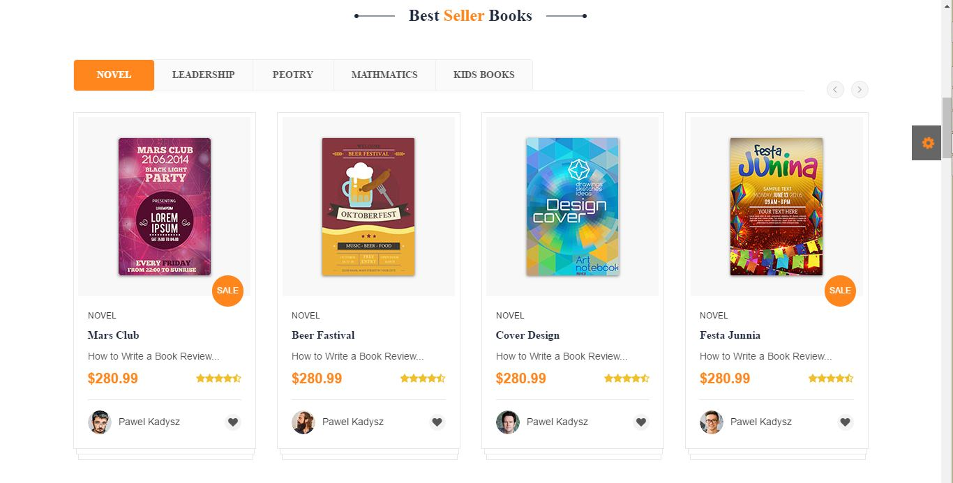

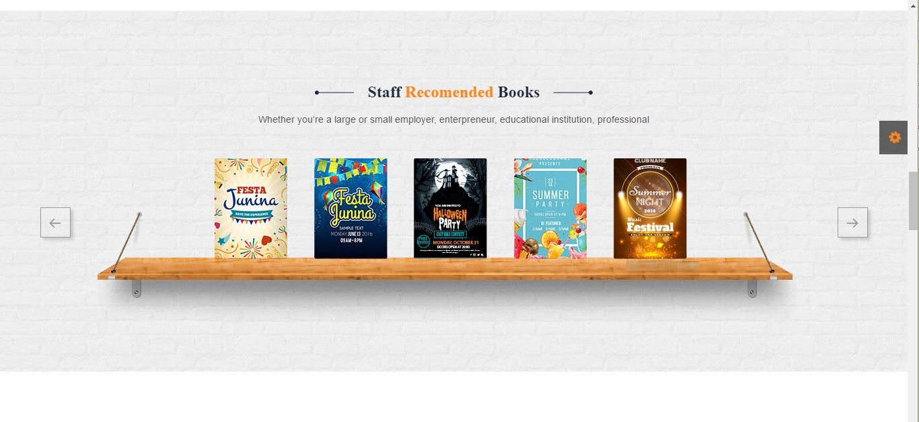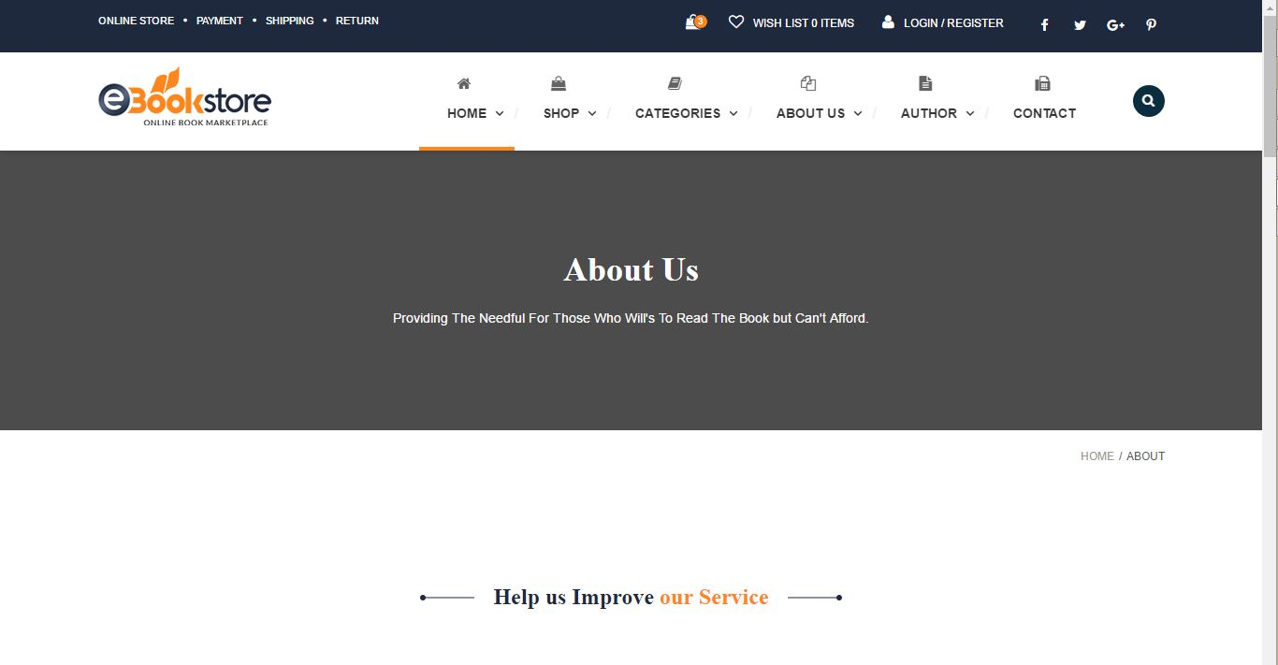

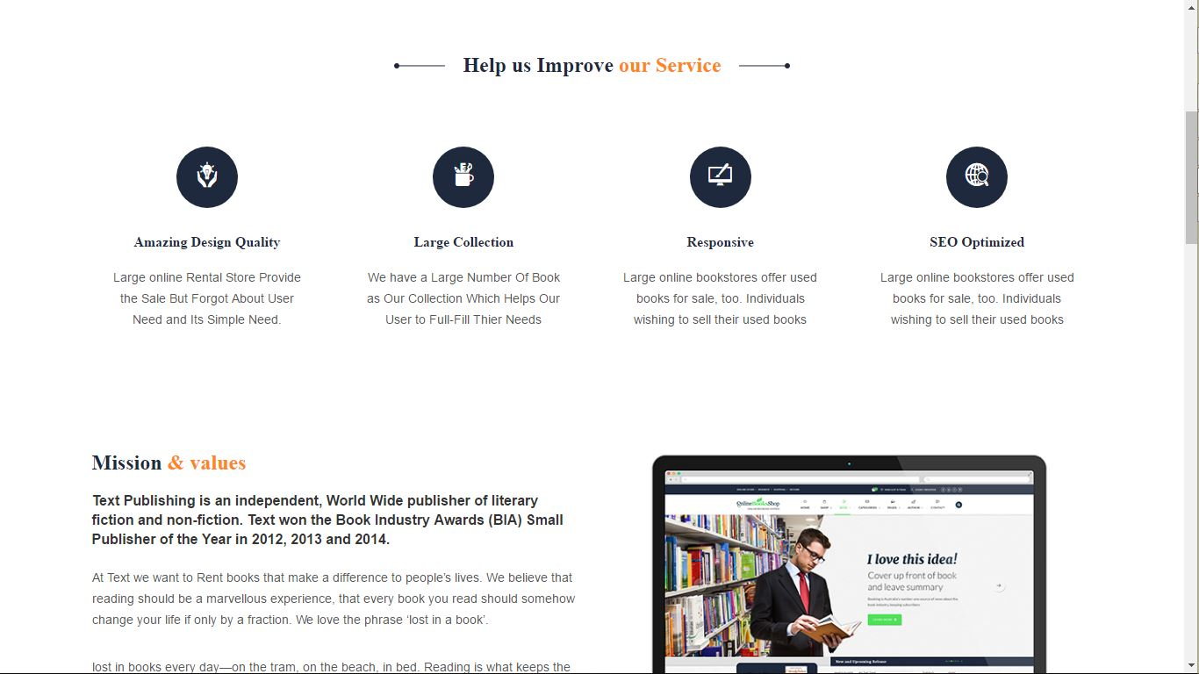

* + 1. **Login:**

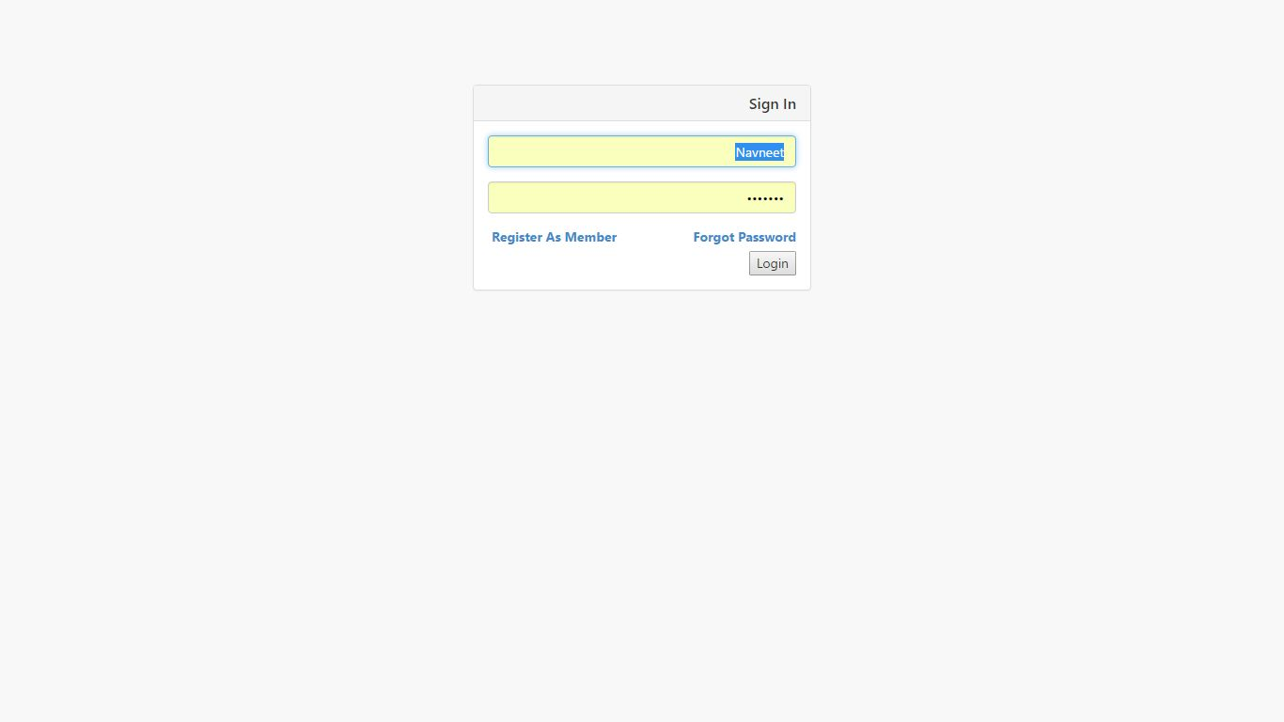

* + 1. **Management Panel**

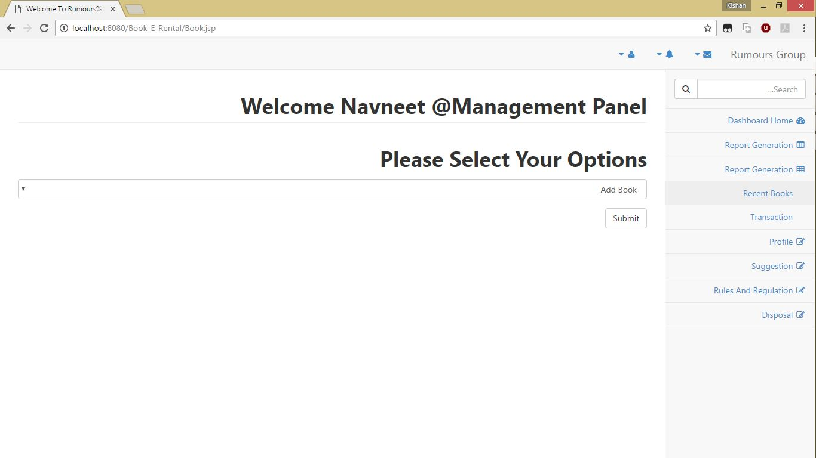

* + 1. **Register:**

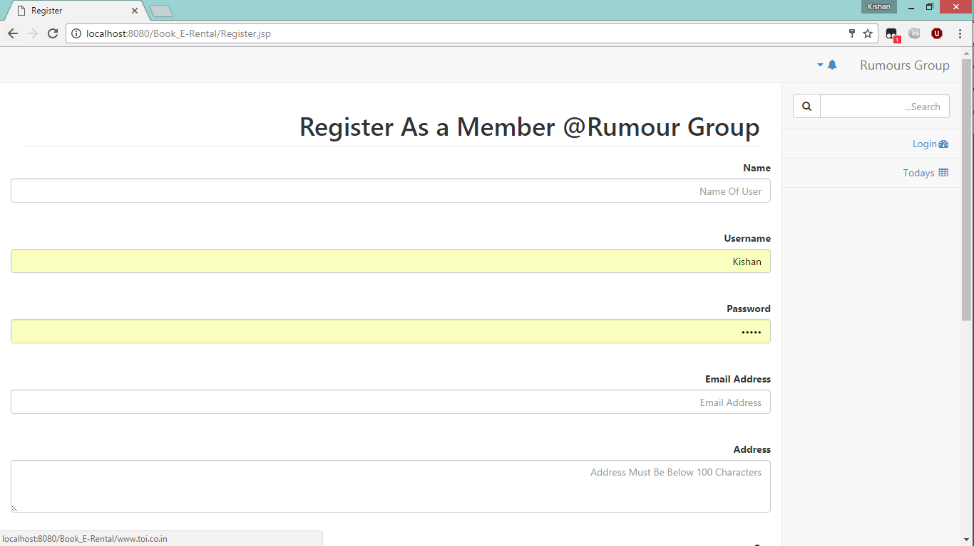

* + 1. **Forgot Password:**

**STEP 1:**

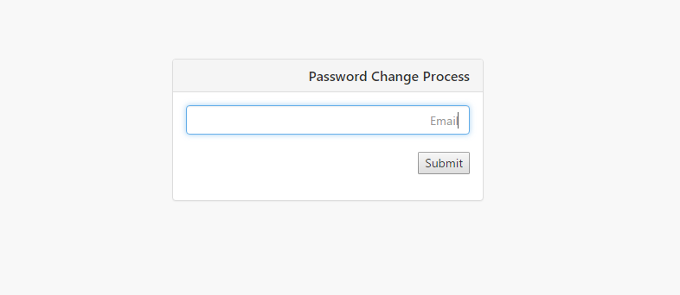

**STEP 2: After E-mail Verification**

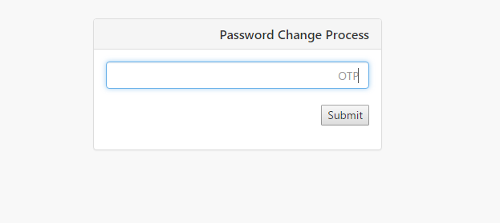

**STEP 3: After OTP get Verified:**

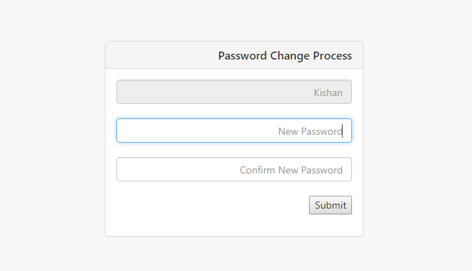

* + 1. **Admin/User Dashboard:**

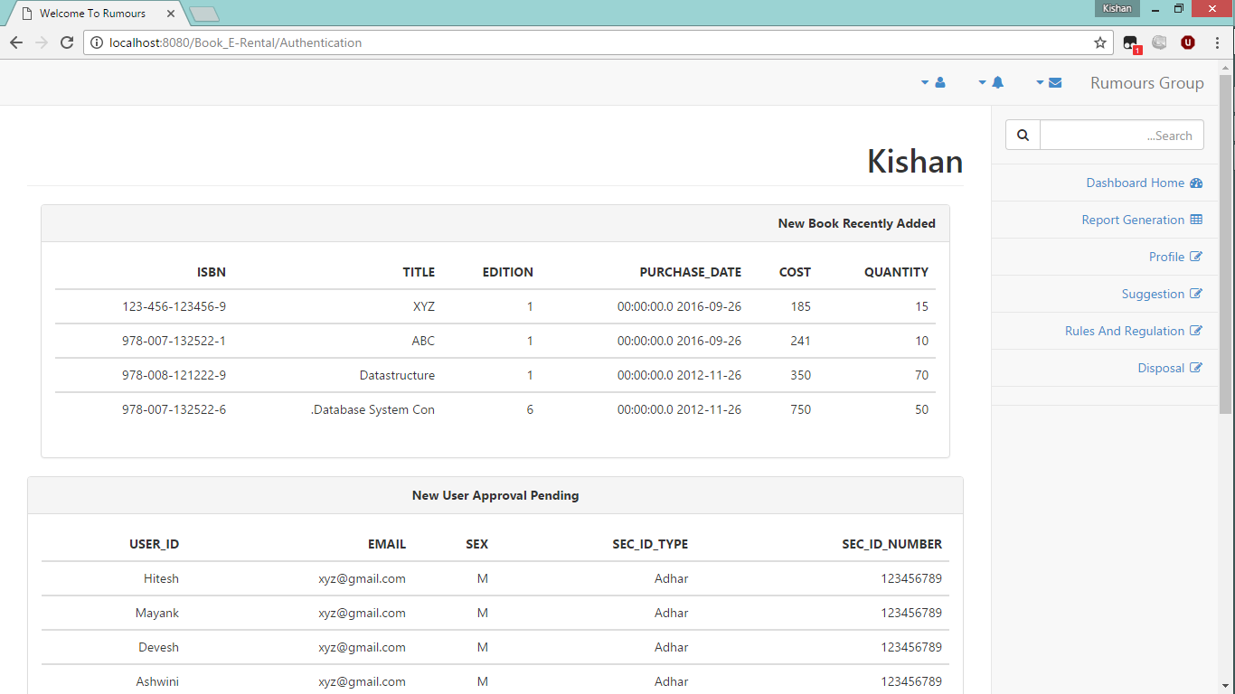

* + 1. **Profile:**

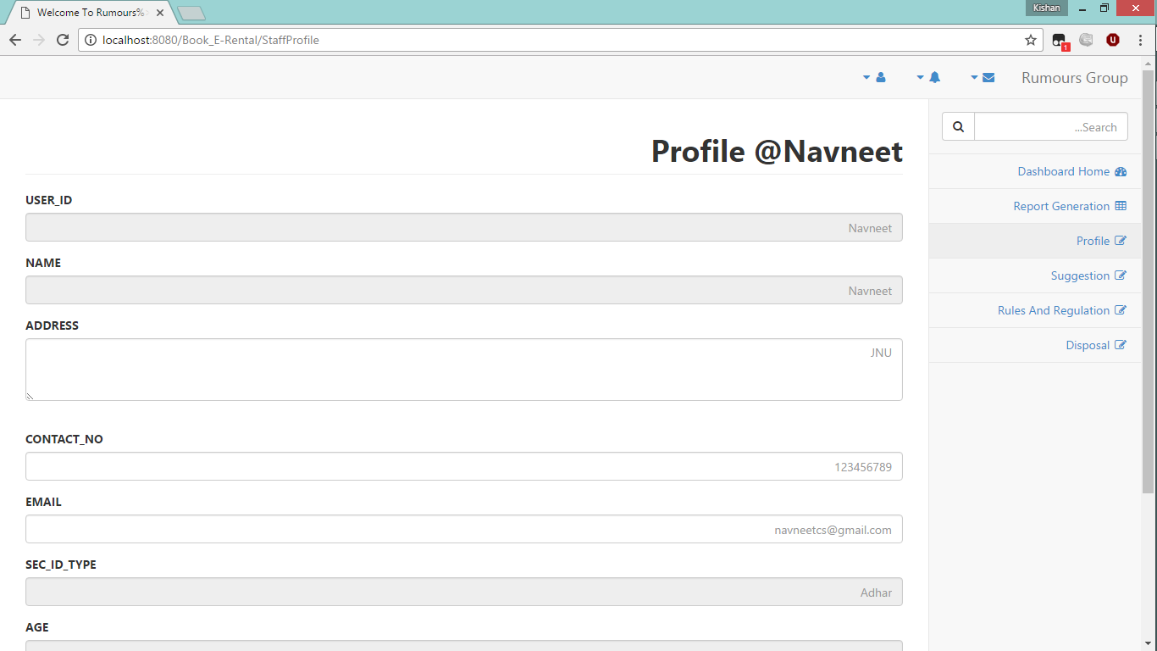

**Note:** Full Image can’t be show because of Clarity and length of the image but basic work is shown.

We have not provided the Access to change the permanent data.

* + 1. **Suggestion Registered by User:**

**STEP 1:**

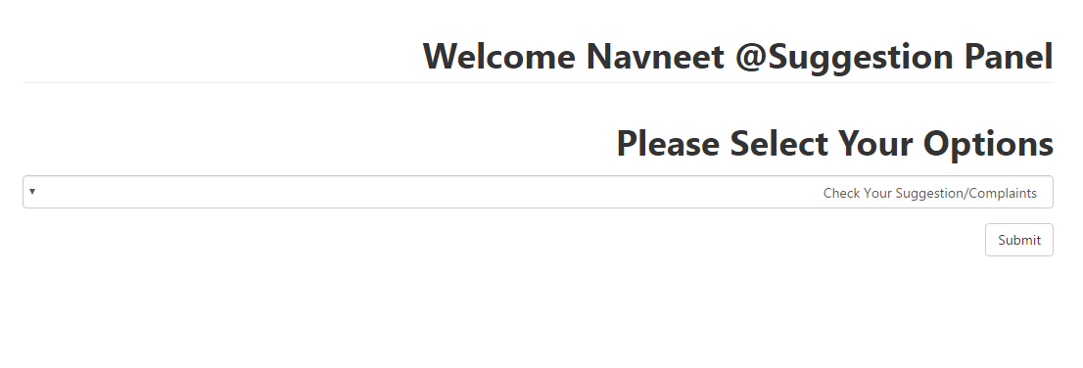

**Note -: In Step 1 We have given two options as followed:**

1. **Check your suggestion or complaint.**
2. **Register your Suggestion and Complaint.**

**STEP 2-: Register Your Complaint/Suggestion.**

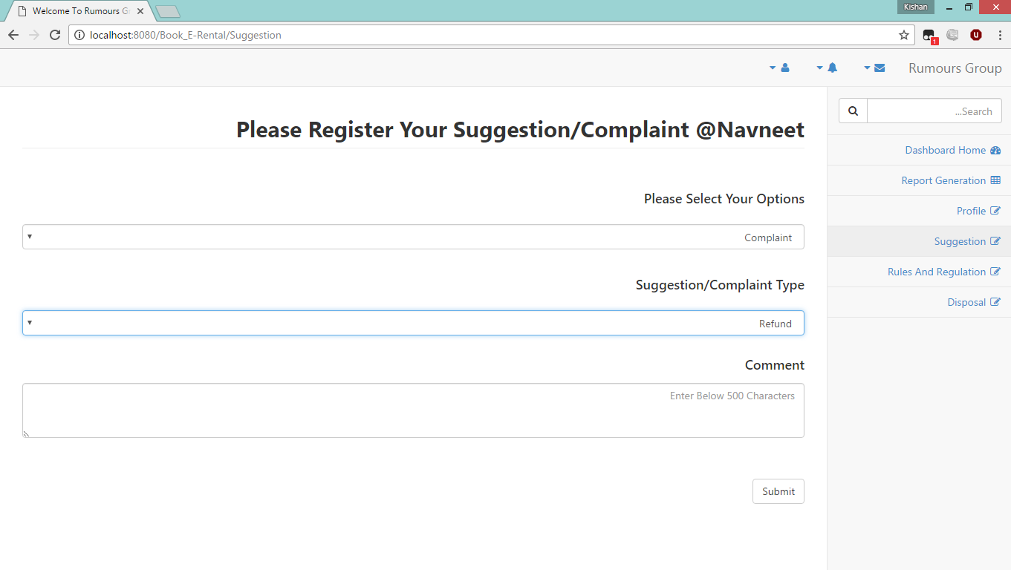

**Note: Suggestion/Complaint Type are As Followed.**

1. **Book Collection**
2. **Facility**
3. **Book Condition**
4. **Enhancement of Policy.**
5. **Loan Policy.**
6. **Fine Policy.**
7. **Transaction.**
8. **Timing.**
9. **Pick Up Policy Etc.**
10. **Implementation**
    1. **Application Server Setup / Configuration**

The Application Used in Project Development is -:

1. **NetBeans -:** The Different API which is Listed Below is Added in Library Folder of the project in NetBeans. We used Junit and JRebel for Our Code betterment and formation of code. They also work as Unit Testing Tools These can be found in NetBeans Plugin list.
2. **Apache Tomcat / Glassfish Server -:** While Setting Upthe Server we need to setup the Server port address and username and password but NetBeans self-configures them.

But for my Testing Purpose I have used Apache Tomcat 9.0 as a server we deployed our project on Apache Tomcat.

To Deploy an Application on Tomcat we need to first make a war file of Our Project with correct Directory Structure.

Code to Make War File-: jar –cvf ProjectName.war *

While installing the Tomcat Server we need to set the The port no. and Username and password.

On Browser we need to user URL-: localhost:port no.

When the Homepage of Apache Tomcat Appears then we need to select manage app their we get deployment option.

1. **Browser-** The Project Is formed by making Chrome and Firefox in as Common Browser So it May Happen Some Presentational problem Occur in Other Browsers.
   1. **Database Server Setup / Configuration**

**Oracle 10g -:** Is used as my Database Server in project we need to add the **jdbc14.jar** file in our Library folder to access the Database Sever Connectivity.

The File is present where we installed the oracle like I have installed in C:/ Drive Example-: C:\oracle\product\10.2.0\db_1\jdbc\lib\ojdbc14.jar.

* 1. **API Used.**
     1. **Itext.jar (**For PDF Generation).
     2. **Jakarta Api (**For Data Manipulation)
     3. **Struts 2.0 API (**For Better Configuration).
     4. **Java Mail API (For Future OTP Management).**

1. **References**
   1. **Amazon Kindle Concept-(Amazon.in/Book)**
   2. **Jaipur National University E-Library (192.168.15.108)**
   3. **COCOMO Model for E-Commerce Application**

**By-: Ramesh Kumar**

Department of Computer Science & Engineering, NIET, NIMS University Jaipur

* 1. **Doorstep Books -:** <http://www.doorstepbooks.com>.